Point
- Refresh after restor in Ean Packing (https://siameats.net/eanPacking)
when press this procedure works, but there is no green that comes and says done and no refresh, I already mentione dthis at least 6 times
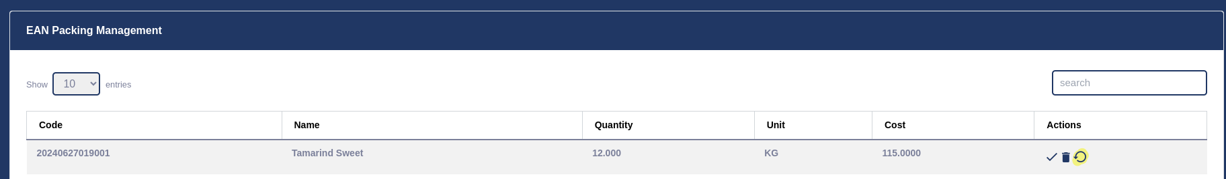
- PDF
- Payments (works okay in client please make it under main https://siameats.net/dashboard also work)
- Claims
- ICONS OPEN IN NEW TAB OR MODAL FOR ALL FOR STATEMENT OPEN IN NEW TAB BOTH CLIENT AND CONSIGNEE
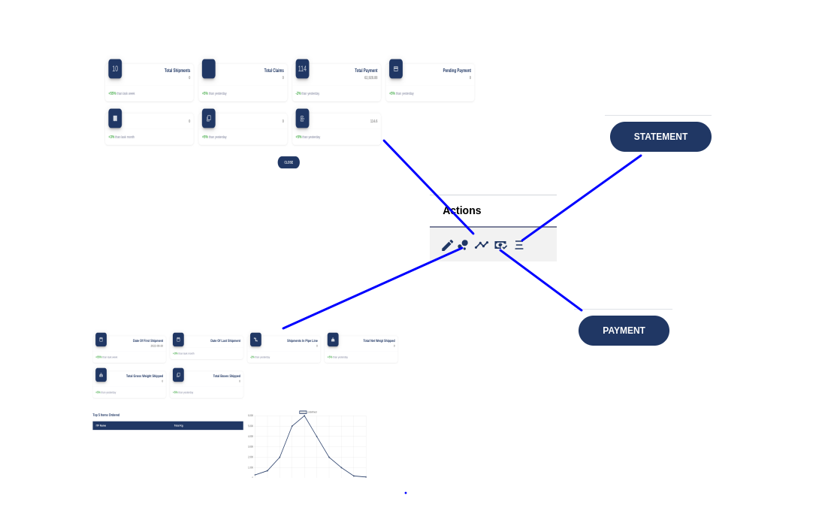
- YELLOW ICONS STATUS 2 AND UP HIDE PINK AT 2 BECOME AVAILABLE

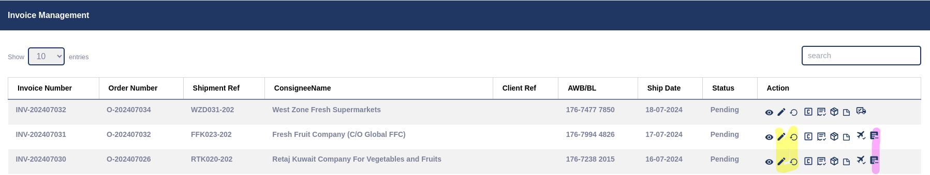
- Below ICON CHANGE WITH PROCEDURE Invoice_AWB_Ready AND CHANGE ICON TO DOWNLOAD

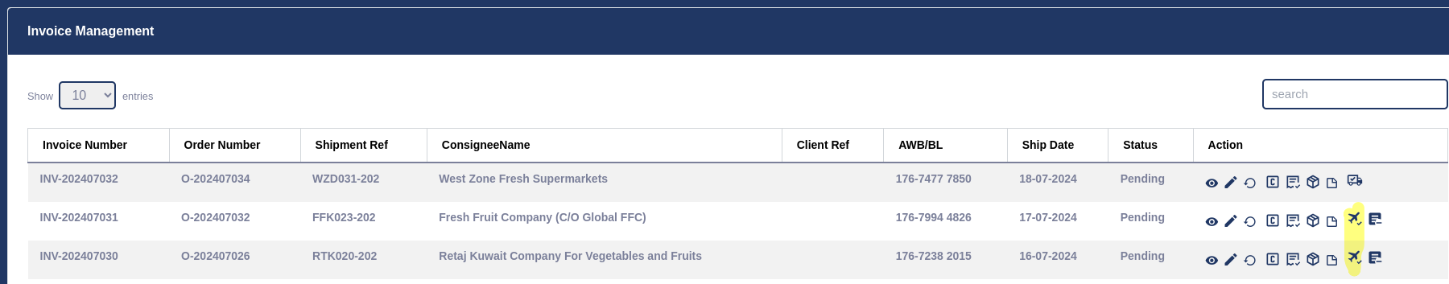
- WHEN USE CUSTOMZED PRICING IN Invoice THE TOTAL IS WRONG NEED TO ADJUST THE sum(cUSTOMIZED PRICE * ITF QUANTITY)
- complete c.SIAMEATS.NET

